Approach note for Assessment template creation for M&HCV Fleet Size

Document History:

Version | CR# | Date | Created By | Reviewed By | Comment
1.0 | 1-15994201035 | 06/06/2012 | Kuldeep Pareek
 |  |  | 07/06/2012 | Naveen Bharadwaj
 |  |  | 07/06/2012 | Sujeet Swain
1.1 |  |  | 29/06/2012 | Kuldeep Pareek
1.2 |  |  | 04/07/2012 | Kuldeep Pareek | Fleet Size to be editable field
Table of Contents
1. Introduction 4
2. Requirement Statement / Problem Statement 4
2.1. Statement 1 4
3. Application Impact Analysis: 4
4. Proposed Solutions: 4
4.1. Solution 1 4
5. CRM Application and Version: 7
6. How to Proceed: 7
7. Open Items: 7
8. Known Risk: 7
9. Appendix: 7

Introduction
Opportunity Screen provides all details of Opportunity like Personal information, Customer segment, Customer Type, Product Information etc. TMCV Business wants to capture the “M&HCV” Vehicle fleet Size information of customer. This information will provide the Competitor and existing fleet size of interested customer.

Requirement Statement / Problem Statement

Statement 1
- TMCV Business wants to capture the Fleet size of TML and NTML “M&HCV” vehicles at Opportunity Screen. This Field will provide Fleet size owned by customer.

Application Impact Analysis:

Sr. No. | Application Impacted | Y/N
1 | OLTP
1.1 | E-automotive | Y
1.2 | Showroom | Y
1.3 | Workshop | N
1.4 | Call Centre | N
1.5 | Distributor | N
1.6 | E-customer | N
8 | OLAP | N
9 | Cordys | N
10 | SAP/IS Auto | N
11 | WOW/VCM | N

Proposed Solutions:

Solution 1
- New Assessment Templates will be created with template name “Customer Fleet Size”
- There will be two Assessment Attributes for this Template: (Outside SRF Activity)
  - TML M&HCV Fleet Size
  - Non TML M&HCV Fleet Size
- “Fleet Size” Will be maintained as attribute value.

- Assessment Template is Maintained at following Path:
Administration-Data / Sales Assessment Templates / Customer Fleet Size

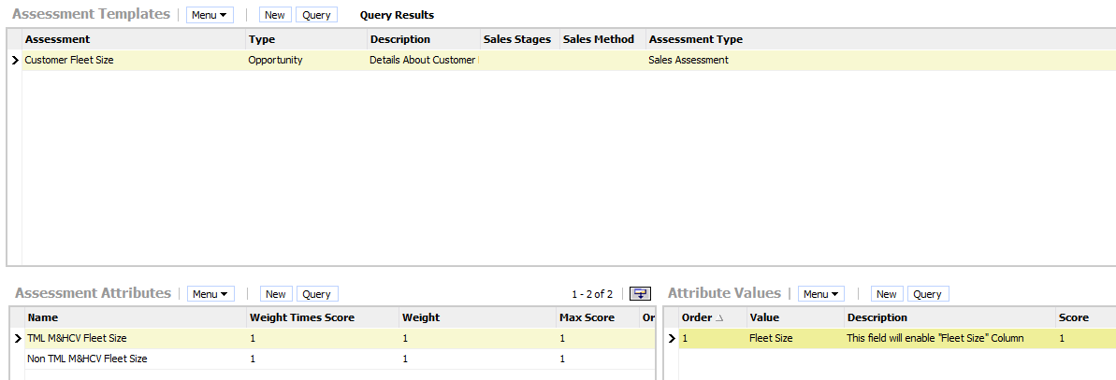

Screen:
  Data Administration Screen
View:
  Sales Assessment Admin View
Business Object:
  Sales Assessment
Applets:
  Applet[0]: Sales Assessment Admin List Applet; Applet[1]: Sales Assessment Attribute Admin List Applet; Applet[2]: Sales Assessment AttVal Admin List Applet;
Business Components:
  BusComp[0]: Sales Assessment Template; BusComp[1]: Sales Assessment Attribute; BusComp[2]: Sales Assessment Attribute Value;

- “Fleet Size” will be drop-down in Assessment Value. When user will pick the “Fleet Size” Value. New column “Fleet Size Value” will become editable and user will put values in the column.

Step 1: User will select the assessment “Customer Fleet Size”

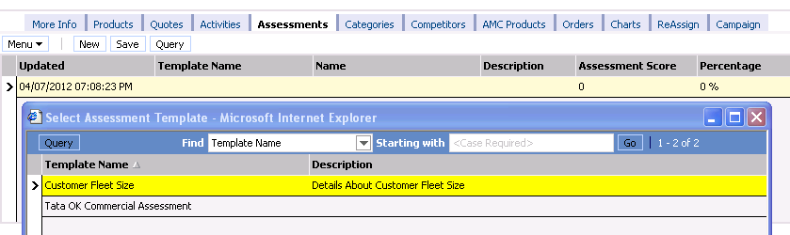

Step 2: User will enter desired Fleet Size value.

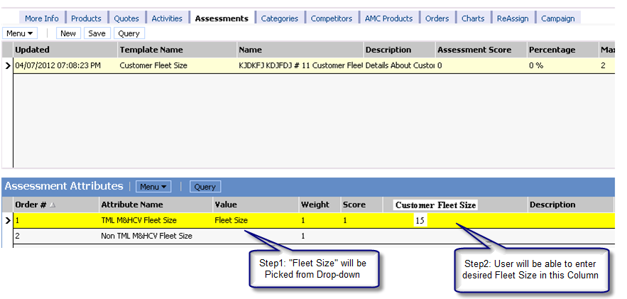

Opportunity > Assessment Screen details:

Screen:
  Opportunities Screen (SCW)
View:
  Opportunity Assessment View
Business Object:
  Opportunity
Applets:
  Applet[0]: Opportunity Form Applet - Child; Applet[1]: Sales Assessment List Applet(Opty); Applet[2]: Sales Assessment Value List Applet;
Business Components:
  BusComp[0]: Opportunity; BusComp[1]: Sales Assessment; BusComp[2]: Sales Assessment Value;

- NOTE: “Customer Fleet Size” Field should be read only until “Fleet size” LOV is picked from bounded pick list (Value). As soon as “Fleet Size” Value is selected. New Field “Customer Fleet Size” should become editable.

- New Field “TM Sales assessment BU” will be introduced in Assessment Template Screen; this field will drive visibility of template. Eg. If BU is “TMCV”, this template should be visible to TMCV BU user only.

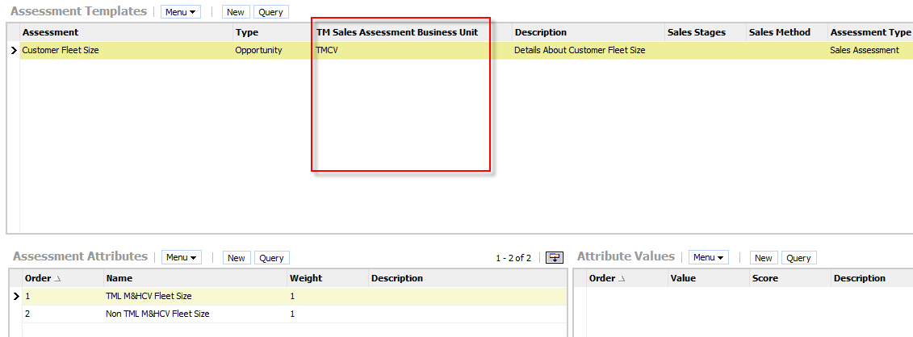

- Assessment Screen tab is available with Following View:
  - Opportunity Assessment View

- This View will be given to following TMCV Responsibilities:

TMCV DSAdmn
TMCV DSE
TMCV DSM
TMCV DSCo

CRM Application and Version:
Siebel Version: OLTP 8.1.1.5
Applications: e-automotive, Showroom

How to Proceed:
http://172.24.29.53/eautomotive_enu/
http://172.24.29.53/showroom/

Login details:
Application | Position Type | User Id | Password
e-automotive |  | PRDUSER2 | DPRDUSER2
Showroom | TMPC DSAdmn | ADMINFN3000380 | TATA2010
 | TMCV DSAdmn | VYADAV1003530 | TATA2010
 | TPCD DSAdmn | VTARANG_9943525 | TATA2010
 | TMCV DUvPE | VINAYA1001680 | TATA2010

Open Items:
- Currently, Assessment attributes will be created for M&HCV only; there is provision to add the same for other LOB as per business requirement.

Known Risk:
N.A

Appendix:
N.A

